**NAME: FAISAL RASOOL QAZI**

**ROLL NUM: 455689**

**FOP 05 HOME TASKS**

**//TASK 1**

#include <iostream>

using namespace std;

int HCF(int a, int b) {

if (b == 0)

return a;

return HCF(b, a % b);

}

int LCM(int a, int b) {

return (a * b) / HCF(a, b);

}

int main() {

int num1, num2;

cout<<"Enter first number: ";

cin>>num1;

cout<<"Enter second number: ";

cin>>num2;

int lcm=LCM(num1, num2);

cout<<"Their LCM is "<<lcm<<endl;

return 0;

}

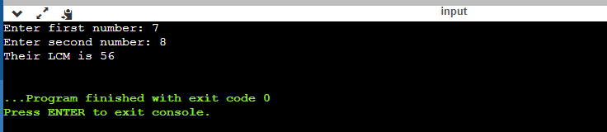

**// TASK 2**

#include <iostream>

using namespace std;

int main() {

int a, d, n, s;

cout << "Enter first term: ";

cin >> a;

cout << "Enter the common difference: ";

cin >> d;

cout << "Enter the number of terms: ";

cin >> n;

int sum = (n*(2*a+(n-1)* d))/2;

cout << "s = " << sum << endl;

return 0;

}

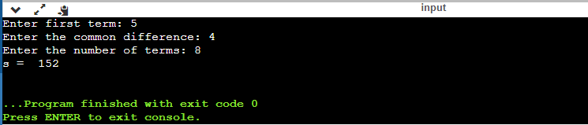

**//TASK 3**

#include <iostream>

using namespace std;

int main() {

int rows;

cout << "Enter the number of rows: ";

cin >> rows;

for (int i = 1; i <= rows; i++) {

for (int j = 1; j <= rows - i; j++) {

cout << " ";

}

for (int k = 1; k <= 2 * i - 1; k++) {

cout << "*";

}

cout << endl;

}

for (int i = rows - 1; i >= 1; i--) {

for (int j = 1; j <= rows - i; j++) {

cout << " ";

}

for (int k = 1; k <= 2 * i - 1; k++) {

cout << "*";

}

cout << endl;

}

return 0;

}

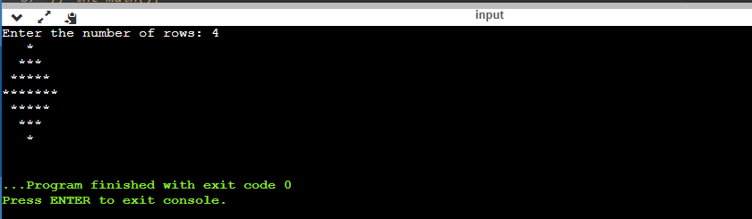

**// TASK 4**

#include <iostream>

using namespace std;

int main(){

int dn, bn[30], i=0;

cout<<"Enter a decimal number to convert it into binary number: ";

cin>>dn;

while(dn!=0){

bn[i] = dn%2;

i++;

dn=dn/2;

}

bn[i]='0';

cout<<"Its binary conversion is ";

for(i=i-1;i>=0;i--){

cout<<bn[i];

}

}

